**CPSC 50100 Assignment 5**

|  |
| --- |
|  |
|  |  |

|  |
| --- |
|  |
|  |  |

1. QR Codes, short for "quick response" codes, are little black and white squiggly barcodes (shown below). Marketers adopted these QR codes because of their large storage capacity and ability to translate additional information. Your task is to make a QR generator to simulate this QR image (shown below) by using some of Java FX shapes. Remember in Java, all visible points have positive coordinates like:



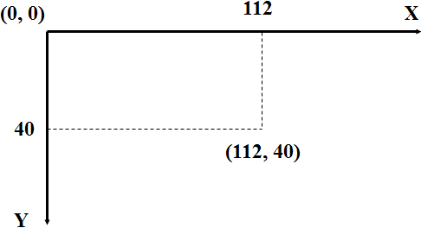

So, a rectangle is specified by its upper left corner and its width and height in the panel:

Rectangle(x, y, width, height);

Rectangle r = new Rectangle(30, 50, 200, 70);

Also, remember to use

rect.setFill(Color.BLACK);

Try to make a 512 x 512 image first so that you can generate a QR code. You may need to generate a random numbers among three large squares surrounded by black lines. Please use a black and white values only (i.e., 0: black and 1: white). In a matrix, if you start with all white values (i.e., every value is 1), then your task is to convert some of the values to 0s to make it look like a QR code. From time to time, you need to make sure the QR code you are building is in a right direction by imshow() command. Think about using rand() associated with round() to make the values as 0 or 1. repmat() command can also be used.

Please send me the source code you designed (55 points).